Personnel responsible:
All Production

Safety equipment:
Personal Protective Equipment (PPE): Acid Suits, Acid Boots, Acid Gloves, Face Shields, and Chemical Resistant Goggles

Summary:
To ensure all Acid Personal Protective Equipment (PPE) is properly stored and maintained.

Procedure:
- Any employee dealing with Acid must have appropriate Acid Gear.
- Acid Suits will be supplied to Material Handlers, Assistant Operators, Lead Operators, Maintenance, Warehouse Loaders, and Production Management.
- Acid Gear consists of Acid Suit, Acid Boots, Acid Gloves, Face Shield, and Chemical Resistant Goggles.
- Personal Protective Equipment (PPE) is the responsibility of the employee therefore; any employee with Acid Gear must put their initials with black marker on the suit, gloves, boots, face shield, and goggles.
- Material Handlers, Lead Operators, Assistant Operators, Warehouse Loaders, Production Management, and Maintenance will be supplied lockers to store Acid Gear.
- Acid Gear must be stored properly in locker. Storing PPE properly allows employees to safely and quickly access equipment if needed.
- Acid Suits must be hung up in locker. Acid Gloves must be stored on shelf in locker. Acid Boots must sit upright together at the back of locker. Face shields must be hung up or stored on shelf in plastic cover. Employee “MUST” rinse off suit with water if acid gets on suit Gear and should be worn at all times in. (Please See Pictures of Proper Storage Below).
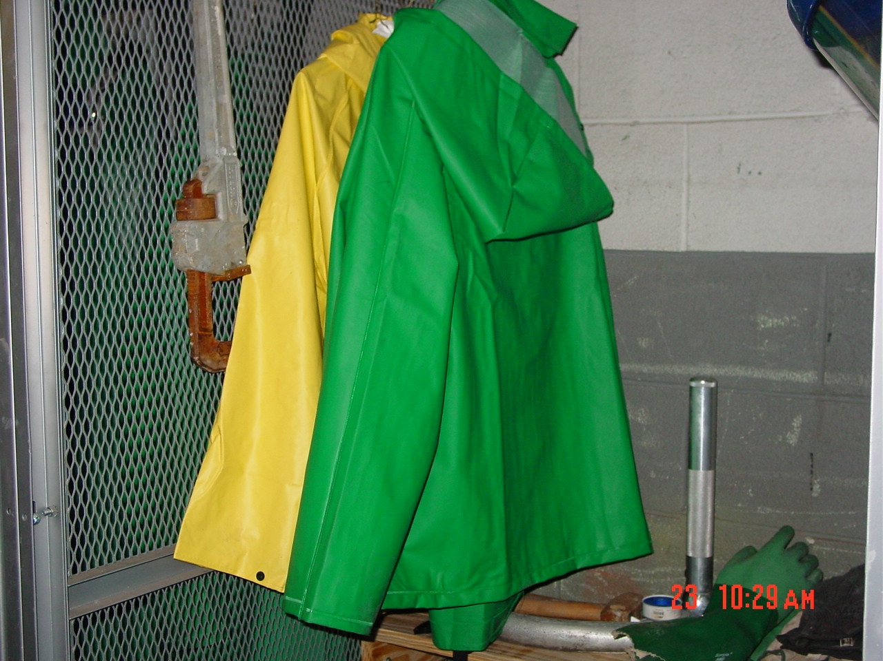  PPE – Jackets and Pants are always Hung neatly on hangers | 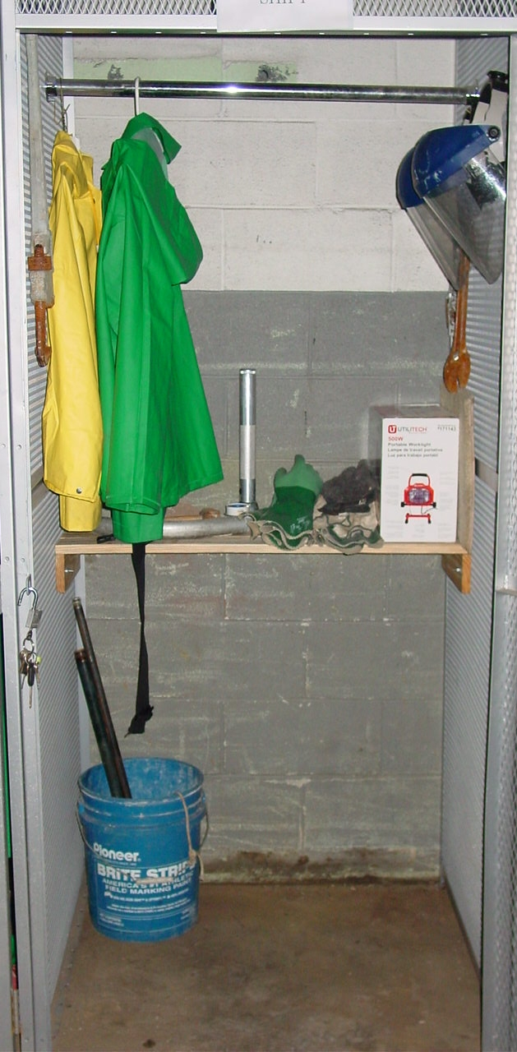 | 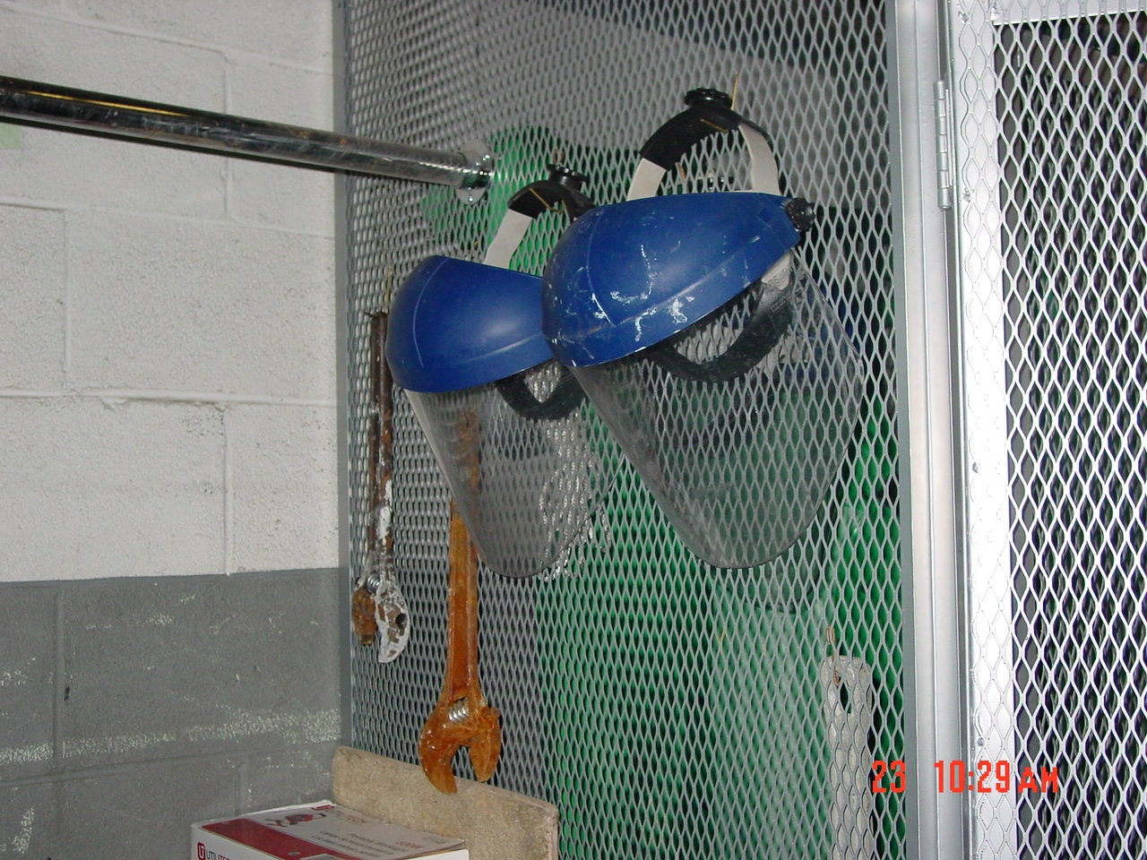  Shields neatly hung  All tools hung neatly

- Acid Gear is “NOT” to be left anywhere in the production areas. Acid Gear may be worn if employee is performing clean-up in production areas but remember the gear is the responsibility of employee therefore; employee must make sure gear has no tears or holes. Boots may be worn at all times during the shift but employee must make sure boots have no holes or tears. If you are not using your gear it” MUST” be stored in locker properly. If employee does not store Acid Gear properly or leaves any part of gear lying around the production areas they will face disciplinary action.
- Employee is “REQUIRED” to inspect their acid gear every Monday of their day shift. Employee will inspect suit, gloves, and boots for holes and tears. Employee will inspect face shield for cracks and scratches. Production Management, Maintenance, and Warehouse Loaders are “REQUIRED” to check acid gear once a month due to the limited usage of gear. If the acid gear is used then Warehouse Loaders, Maintenance, and Production Management are “REQUIRED” to check after usage.
- Employee must fill out log sheet for Acid Gear Inspection. Log Sheets must be turned into Safety Department. If there are any problems with Acid Gear it “MUST” be reported to Safety Department immediately. This allows employee to get new equipment if needed.
- Safety Department will be responsible for ordering all acid gear. Safety Department will keep one spare acid suit and boots in every size in inventory. Safety Department will keep gloves and face shields in inventory.
- Acid Gear is not to be loaned out to another employee. If an employee has a suit with tears or holes and has no access to get a new suit then they can not off load acid. It is the employee’s responsibility to make sure they have PPE for their shift. Report immediately if you have a problem with your gear.

ACID GEAR CHECK

Name: ____________________

Date: _____________________

Position: ______________________

Acid Gear | Ok | Not OK | Problem | Action Taken
Jacket
Pants
Gloves
Boots
Face Shield

Signature: ________________________________________________________________________

TRAINING DOCUMENTATION

 | EMPLOYEE | TITLE | SIGNATURE | DATE
1
2
3
4
5
6
7
8
9
10
11
12
13
14
15
16
17
18

Revision  Number | Revision  Date | Revision  Author | Revision Description
00 | 03/23/2009 | SL | New Document

